Dear Swim Team Coach,

Greetings!

We are pleased to invite your Swim Team, to the 2012 Andy Apostol Swim Meet to be held in the Amoranto Sports Complex Swimming Pool on Sunday, 4 March 2012 from 6am to 5pm.

If you decide to accept our invitation, please send us an estimate of the number of swimmers attending by sending the REGISTRATION FORM back before 18 February 2012.

Please refer to the event list and meet details for information. The minimum age for entry is 6 years old. There are no qualifying times. Swimmers may enter a maximum of 5 individual events and 2 relay events. Swimmers aged 8 years old and under are only permitted to join 50M events for freestyle, backstroke, breaststroke, and butterfly and the 100 freestyle events. Full details are attached for your perusal.

We hope to hear from you soon and if you have any queries please do not hesitate to contact us.

We look forward to seeing you in March!
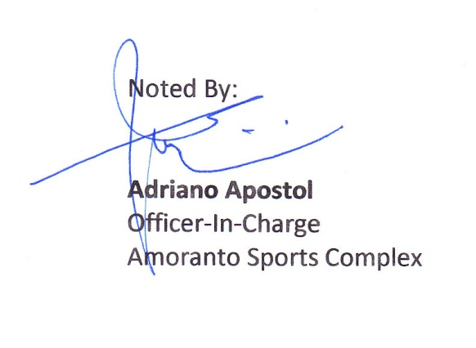

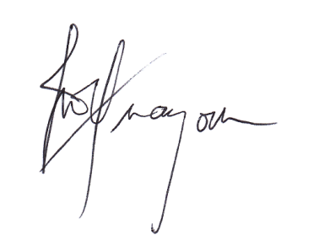
Sincerely,

Melody T. Tuazon
Co-Chair, Redpoint Enterprise
Organizing Committee
0918.941.56.17/496.95.38

Meet arrangements and entries:

DATE : March 4, 2012 (Sunday )

VENUE : Amoranto Sports Complex Swimming Pool

AGE GROUPS : 18 and Over
15-17
13-14
11-12
10 and under

GOVERNING RULES : 1. A swimmer can compete in a maximum 5 individual
events and 2 relays.

2. Age of Reckoning is Jan. 1, 2012

3. Competition will be for one (1) day only.

4. PROTEST must be submitted within 20 minutes after the event was swum. PROTEST shall not be entertained after the said time. Only the coach or the team manager shall be entertained when a protest is made.A protest fee in the amount of 2,000 is required for the protest to proceed.

5. Point system will be as follows:
9 points for 1st place
7 points for 2nd place
6 points for 3rd place
5 points for 4th place
4 points for 5th place
3 points for 6th place
- points for 7th place
- point for 8th place

* TYPE OF MEET : Timed Finals

SCHEDULE : 6:00 am – 8:00 am : Warm-up
NOTE : Open lanes during warm-up
Lane’s 2-7 warm-up lanes
Lanes 1&8 sprint lanes
8:00 am – 8:15 am : Coaches Meeting
8:15 am – 8:30 am : Flag Ceremony
8:30 am : Start of competition

AWARDS : Over-all Team Point Championship from 1st to 3rd place.
Medals for 1st, 2nd, and 3rd place. Most Outstanding trophy per age group

ENTRIES :

Submit all entries to either one of the following persons:
- Rowena Baldonado (winnie_baldonado2@yahoo.com)
- Cyrus Alcantara

Registration fee is 400 per swimmer. Payment made before the start of the competition or can be deposited at Metrobank current account no.:7-198-90162-4 / account name: Melody Tuazon (09189415617). Please keep the deposit slip for verification of payment.

Deadline of entries is on February 27, 2012 (Monday)

Should you have any queries, please do not hesitate to contact us. Please direct all correspondence or inquiries to Cyrus Alcantara. Mobile No. 09228333566.

SPONSORSHIP :

Sponsorship opportunities are available for interested parties. For inquiries, please call: Mels Tuazon - 0918.941.56.17 or 496.95.38

FOOD CONCESSIONAIRES:

For your convenience, a variety of food stalls are available during the event proper for your lunch and snack purchases. A limited number of vendor slots are still open. For inquiries, please contact: Darlyn Rosal –0919.248.79.54 or 393.49.67

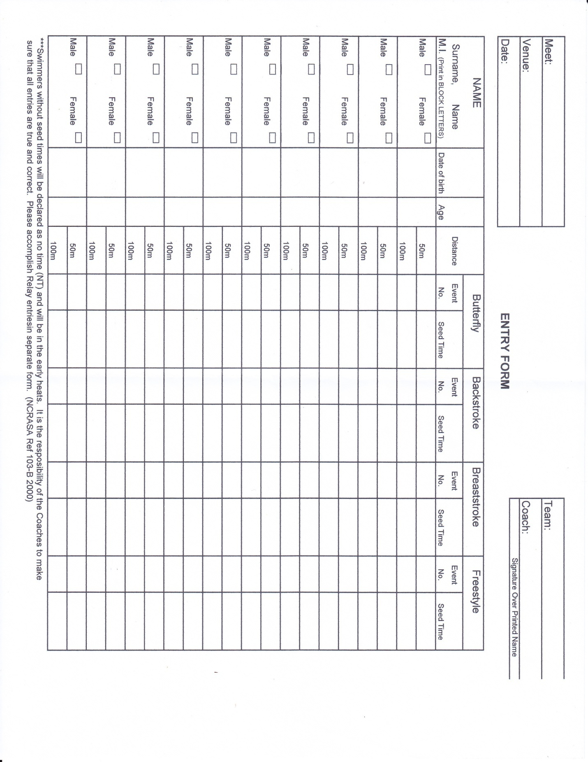

MALE | ANDY APOSTOL SWIMFEST 2012 |  | FEMALE
1 | 100 Fly | 11 to 12 | 2
3 | 100 Fly | 13 to 1`4 | 4
5 | 100 Fly | 15 to 17 | 6
7 | 100 Fly | 18 and over | 8
9 | 50 Back | 10 and under | 10
11 | 50 Back | 11 to 12 | 12
13 | 50 Back | 13 to 1`4 | 14
15 | 50 Back | 15 to 17 | 16
17 | 50 Back | 18 and over | 18
19 | 100 Breast | 11 to 12 | 20
21 | 100 Breast | 13 to 1`4 | 22
23 | 100 Breast | 15 to 17 | 24
25 | 100 Breast | 18 and over | 26
27 | 50 Free | 10 and under | 28
29 | 50 Free | 11 to 12 | 30
31 | 50 Free | 13 to 1`4 | 32
33 | 50 Free | 15 to 17 | 34
35 | 50 Free | 18 and over | 36
37 | 4x50 Medley Relay | (Stair Step) | 38
39 | 4x50 Kickboard Relay | Open | 40
LUNCH BREAK
41 | 50 Fly | 10 and under | 42
43 | 50 Fly | 11 to 12 | 44
45 | 50 Fly | 13 to 1`4 | 46
47 | 50 Fly | 15 to 17 | 48
49 | 50 Fly | 18 and over | 50
51 | 100 Back | 11 to 12 | 52
53 | 100 Back | 13 to 1`4 | 54
55 | 100 Back | 15 to 17 | 56
57 | 100 Back | 18 and over | 58
59 | 50 Breast | 10 and under | 60
61 | 50 Breast | 11 to 12 | 62
63 | 50 Breast | 13 to 1`4 | 64
65 | 50 Breast | 15 to 17 | 66
67 | 50 Breast | 18 and over | 68
69 | 100 Free | 10 and under | 70
71 | 100 Free | 11 to 12 | 72
73 | 100 Free | 13 to 1`4 | 74
75 | 100 Free | 15 to 17 | 76
77 | 100 Free | 18 and over | 78
79 | 4x50 Freestyle Relay | (Stair Step) | 80
81 | 4x50 T-Shirt Relay | Open | 82

